LOAD BALANCING

PRACTICAL ON ALB
1>create a server-1
- create instance
- name-------server1
- machine---amazon linux
- AZ------1a
- sg------ssh,http,https
- user data
#!/bin/bash
yum update -y
yum install httpd -y
echo "<h1> server1 "$HOSTNAME" </h1>" > /var/www/html/index.html
systemctl start httpd.service
systemctl enable httpd.service
- launch a instance

2>create a server-2
- create instance
- name---server2
- machine---amazon linux
- AZ------1a
- sg------ssh,http,https
- user data
#!/bin/bash
yum update -y
yum install httpd -y
echo "<h1> server2 "$HOSTNAME" </h1>" > /var/www/html/index.html
systemctl start httpd.service
systemctl enable httpd.service
- launch a instance

3>create a target group
- create a target group
- target type------instance
- target name----tgserver
- protocol-----------------http
- health check path-----/
- register targets-------- server1 & server2
- include as a pending below
- create a target group

4> create a application load balancer
- application load balancer
- name------ALB
- scheme----internet facing (publically)
- mapping---1a,1b
- forward to ----> tgserver
- create a load balancer

5> (dns of ALB) -------> hit on web

PRACTICAL ON ALB (PATH BASED ROUTING)
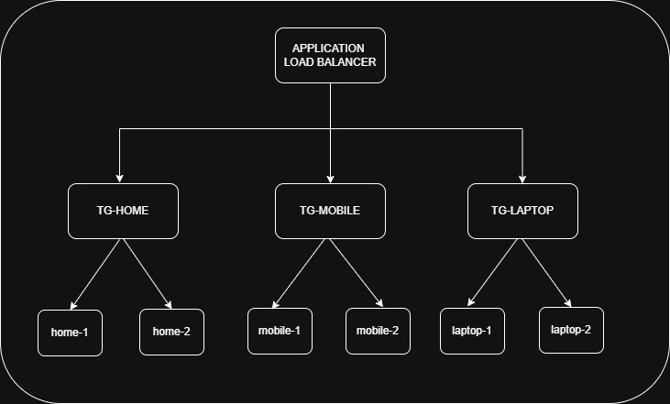
1>create a home instance
- name-------home
- count ------ 2
- machine---amazon linux
- sg------ssh,http,https
- user data
#!/bin/bash
yum update -y
yum install httpd -y
echo "<h1> these is my home instance "$HOSTNAME" </h1>" > /var/www/html/index.html
systemctl start httpd.service
systemctl enable httpd.service
- launch a instance

2>create a mobile instance
- name-------mobile
- count ------2
- machine---amazon linux
- sg------ssh,http,https
- user data
#!/bin/bash
Sudo yum update -y
Sudo yum install httpd -y
Sudo mkdir -p /var/www/html/mobile
echo "<h1> These is my mobile instance of "$HOSTNAME" </h1>" > /var/www/html/mobile/index.html
systemctl start httpd.service
systemctl enable httpd.service
- launch a instance

3>create a laptop instance
- name-------laptop
- count ------2
- machine---amazon linux
- sg------ssh,http,https
- user data
#!/bin/bash
Sudo yum update -y
Sudo yum install httpd -y
Sudo mkdir -p /var/www/html/laptop
echo "<h1> These is my laptop instance of "$HOSTNAME" </h1>" > /var/www/html/laptop/index.html
systemctl start httpd.service
systemctl enable httpd.service
- launch a instance
3>Create A Target Group (Home)
- create a target group
- target type------instance
- target name----tg-home
- protocol---------http
- health check path-----/
- register targets-------- home1 & home2
- include as a pending below
- create a target group

4>Create A Target Group (Mobile)
- create a target group
- target type------instance
- target name----tg-mobile
- protocol------------http
- health check path-----/mobile/
- register targets-------- mobile1 & mobile2
- include as a pending below
- create a target group

5>Create A Target Group (Laptop)
- create a target group
- target type------instance
- target name----tg-laptop
- protocol-----------------http
- health check path-----/laptop/
- register targets-------- laptop1 & laptop2
- include as a pending below
- create a target group
6> Create A Application Load Balancer
- application load balancer
- name-------ALB
- scheme----internet facing
- mapping---1a,1b,1c
- forward to ----> tg-home
- create a load balancer
7>Add rules in the Load Balancer
- click on load balancer
- click on http 80
- manage rules ------> add rules
- condition -----> path -----> /mobile/
- forward to tg ----> tg-mobile
8>Add rules in the Load Balancer
- click on load balancer
- click on http 80
- manage rules ------> add rules
- condition -----> path -----> /laptop/
- forward to tg ----> tg-laptop
5> Paste the domain name
- (dns of ALB) -------> get the home page
- dns of ALB/mobile/ ---------> get the mobile page
- dns of ALB/laptop/ ----------> get the laptop page

CONFIGURE NGINX AS A LOAD BALANCER
1>create a server-1
- name------- server1
- machine---amazon linux
- sg------ssh,http,https
- user data
#!/bin/bash
yum update -y
yum install httpd -y
echo "<h1> server1 "$HOSTNAME" </h1>" > /var/www/html/index.html
systemctl start httpd.service
systemctl enable httpd.service
- launch a instance
2>create a server-2
- name------- server2
- machine---amazon linux
- sg------ssh,http,https
- user data
#!/bin/bash
Sudo yum update -y
Sudo yum install httpd -y
echo "<h1> server2 "$HOSTNAME" </h1>" > /var/www/html/index.html
systemctl start httpd.service
systemctl enable httpd.service
- launch a instance
3>create a server-3
- name------- load balancer
- machine---amazon linux
- sg------ssh,http,https
- launch a instance

4>Access the load-balancer server
- yum install nginx -y
- systemctl start nginx
- systemctl enable nginx
- cp /etc/nginx/nginx.conf /etc/nginx/nginx.conf.backup
- vim /etc/nginx/nginx.conf
Replace the http section & add the following inside the existing http {} block
http {
upstream backend_servers {
server 172.31.11.101; #private_ip of server-1
server 172.31.12.102; #private_ip of server-2
}
server {
listen 80;
location / {
proxy_pass http://backend_servers;
proxy_set_header Host $host;
proxy_set_header X-Real-IP $remote_addr;
proxy_set_header X-Forwarded-For $proxy_add_x_forwarded_for;
}
}
}
- nginx -t
- systemctl restart nginx
5>Access the Load Balancer server
- (public_ip_of_LB_server)
- Refresh the page several times
- You get
1. server-1
2. server-2

LOAD BALANCER WITH THE RULE 40-40-20 WEIGHTED POLICY
1.create a instance
- sudo apt update -y
- sudo apt install nginx -y
- sudo systemctl start nginx
1.create a instance
- sudo apt update -y
- sudo apt install apache2 -y
- sudo systemctl start apache2
3.create a instance
- sudo apt update -y
- apt install openjdk-21-jdk -y
- wget https://dlcdn.apache.org/tomcat/tomcat-11/v11.0.23/bin/apache-tomcat-11.0.23.tar.gz
- tar -xvf apache-tomcat-11.0.23.tar.gz
- cd apache-tomcat-11.0.23
- cd bin/
- ./catalina.sh start
4.create a target group (nginx)
- name------tg-nginx
- type-------instance
- path---------/
- register-------nginx
- create a target group
5.create a target group (apache2)
- name------tg-apache2
- type-------instance
- path---------/
- register-------apache2
- create a target group
6. create a target group (tomcat)
- name------tg-tomcat
- type-------instance
- path---------/
- register-------tomcat-----8080----include as pending below
- create a target group
7.create a load balancer
- name-----------------ALB
- default action-------tg-nginx
- create a load balancer
8.click on created ALB
- select listener------click on listener
- action----------------edit listener
- add target group-----tg-apache2 and tg-tomcat
- add the weighted policy
- tg-nginx----------4---------------40%
- tg-apache2------4 --------------40%
- tg-tomcat--------2---------------20%
9.click on application load balancer that you created
- copy the dns and paste
10.The traffic is on nginx 40%, apache2 40% and in tomcat about 20%

TASK:
- Path-Based Routing using Application Load Balancer (ALB) (home/mobile/laptop/watch)
- Path-Based Routing (Home/Mobile/Laptop) with Custom Ports (8001/8002/8003)
- Configure LAMP server
- ALB Health Check Failure Handling
- ALB Weighted Routing with (40%-40%-20%) Rule
- Nginx as a load balancer

